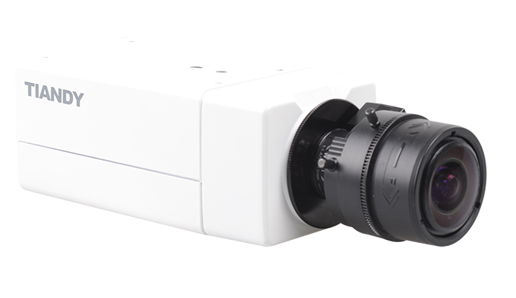

Features

• H.265 Codec  
• Up to 2592×1952 High Resolution  
• 50Hz: 25fps (2592×1952), 50fps (1920×1080)  
• 60Hz: 30fps (2592×1952), 60fps (1920×1080)  
• WDR, 3D DNR, HLC  
• Triple Streams  
• Smart VQD(Video Quality Diagnosis)  
• Smart Facial Detection  
• 19 Kinds of IVA Functions  
• Defog  
• TVS 6000V Protection

Specification

|  |  |
| --- | --- |
| Camera | |
| Image Sensor | 1/2.8″ Sony Exmor CMOS |
| Core Processor | Cortex A7 Architecture Processor |
| Operating System | Embedded Linux |
| Signal System | PAL/NTSC |
| Min. Illumination | Color: 0.05 Lux @(F1.2, AGC ON) |
| B/W: 0.01Lux @(F1.2, AGC ON); 0 Lux with IR |
| Shutter Time | 1/100000s～1s |
| Lens | N/A |
| Lens Mount | C/CS |
| Auto Iris | Y |
| Day& Night | Dual ICR |
| Wide Dynamic Range | 120 dB |
| Digital Noise Reduction | 3D DNR |
| Compression Standard | |
| Video Compression | H.265/H.264/MJPEG |
| Bit Rate | 32Kbps~16Mbps |
| Audio Compression | G.711/G.726/ADPCM |
| Bit Rate | 8K~48Kbps |
| Image | |
| Max. Image Resolution | 2592×1952 |
| Frame Rate | 50Hz:  25fps (2592×1952), 50fps (1920×1080) |
| 60Hz: 30fps (2592×1952), 60fps (1920×1080) |
| Triple Stream | Mainstream: 5MP(2592×1952) |
| Substream: D1(704*576) |
| 3rd stream: D1(704*576) |
| Image Settings | Configurable Brightness, Saturation, Contrast,Flip Mode |
| HLC | Y |
| Smart Defog | Y |
| Corridor | Y |
| EIS | Y |
| ROI | 4 Zones |
| Privacy Mask | 4 Zones |
| Picture Overlay | 200 × 200, BMP 24bit, Zone Configurable |
| Network | |
| Browser | IE 7+, Chrome 18 +, Firefox 5.0 + |
| Network Storage | NAS |
| Video Analytics | Tripwire/Perimeter/Facial detection/People Counting/ Missing&Foreign  object/Crowd/Loitering/Fast Moving/Parking/Off-position/Blurred Image/Audio Offline/Screaming  Detection |
| Alarm Trigger | Motion Detection/IP Conflict/MAC Conflict/Port Alarm |
| Protocols | TCP/IP/ICMP/HTTP/HTTPS/FTP/DHCP/DNS/DDNS/RTP/RTSP/RTCP/PPPoE/NTP/UPnP/SMTP/  SNMP/IGMP/802.1X/QoS/IPv6/Bonjour |
| User Permission | 4 Level/8 Users |
| System Compatibility | ONVIF (Profile S),  SDK |
| Interface | |
| Audio Input | 1-ch 3.5 mm Audio Interface, MIC IN/LINE IN |
| Audio Output | 1-ch 3.5mm Audio Interface (line level, 600 Ω) |
| Communication Interface | 1-ch RJ45 10M / 100M Ethernet Interface and 1-ch RS-485 Interface |
| Alarm Input | 2-ch |
| Alarm Output | 1-ch |
| Video Output | 1-ch Vp-p Composite Output (75 Ω, BNC) |
| On-board Storage | Built-in Micro SD/SDHC/SDXC Card Slot, up to 64 GB |
| Extension | N/A |
| General | |
| Operating Conditions | -35℃～60℃,  0～95% RHG |
| Power Supply | DC 12V±10% AC 24V±10%, PoE (802.3af) |
| Power Consumption | Max 4.5 W |
| Circuit Protection | TVS 6000V, Lightning/Surge 2000V Protection |
| Impact Protection | N/A |
| IR Range | N/A |
| IR LEDs | N/A |
| Dimensions | 145mm×71mm×58mm |
| Weight | 600g (IP Camera Only); 800kg (with Packing Box) |

Dimension

